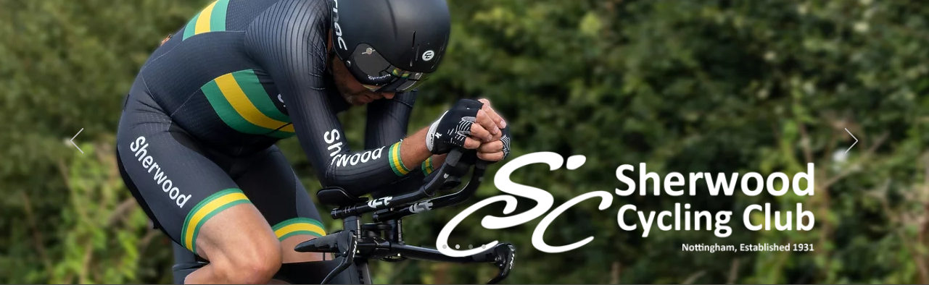

Sherwood Cycling Club 25-mile Open Time Trial 14th August 2021, 1401 hrs
Promoted for and on behalf of Cycling Time Trials under its Rules and Regulations

Organizer Details:
Jez Willows 07813 704 274 jez.willows1@virgin.net
58 Boundary Road
Newark
Notts, NG244AT
Assistant Kevin Humphreys 07504 036 256

Timekeepers:
Mr Norman Portess and Mr Bill Stanley
Assistants Mr Jez Willows and Mr Kevin Humphreys

Course
A25/34

HQ Event Information
Farndon Memorial Hall
Marsh Lane
Farndon
Notts
NG24 3SZ
The HQ will be open from 12:30, Toilet facilities are available but no changing facilities in HQ. Please arrive ready to race. Strictly NO CHANGING IN THE HALL CARPARK as it is near a children’s play area and there have been several complaints at previous events. Any further incidents will result in the loss of the hall as a venue for cycling events.
Please be courteous to residents and other local road users. Do not double park on Marsh Lane or block driveways.
There are several laybys on the old A46 before and after the start and some areas of flat grass verge near Eden hall suitable for parking. Please do not park near to the start.

Course Information
The event is being held on the A25/34 course.
Start 36 yards after speed derestriction sign on southbound exit from East Stoke on the old A46.
Proceed south to Turn Left at traffic island (near Eden Hall) to pass over A46 to Turn Left onto A46 southbound slip road.
On A46, proceed south to take slip road from A46 to new traffic roundabout at junction to Cropwell Bishop & Cotgrave (Stragglethorpe Junction).
Take the 4th exit to pass under the A46 to second roundabout (approx. 10.36 miles.)
Take 3rd exit to slip road onto A46 northbound and proceed towards Newark.
At Farndon roundabout take the first exit onto old A46 (Fosse Way) (Approx. 23.12miles)
Proceed south on old Fosse Way to Finish at start of fence on RHS at gateway to River Trent and just before Stoke Warren Farm on approach to East Stoke. (25.00miles).
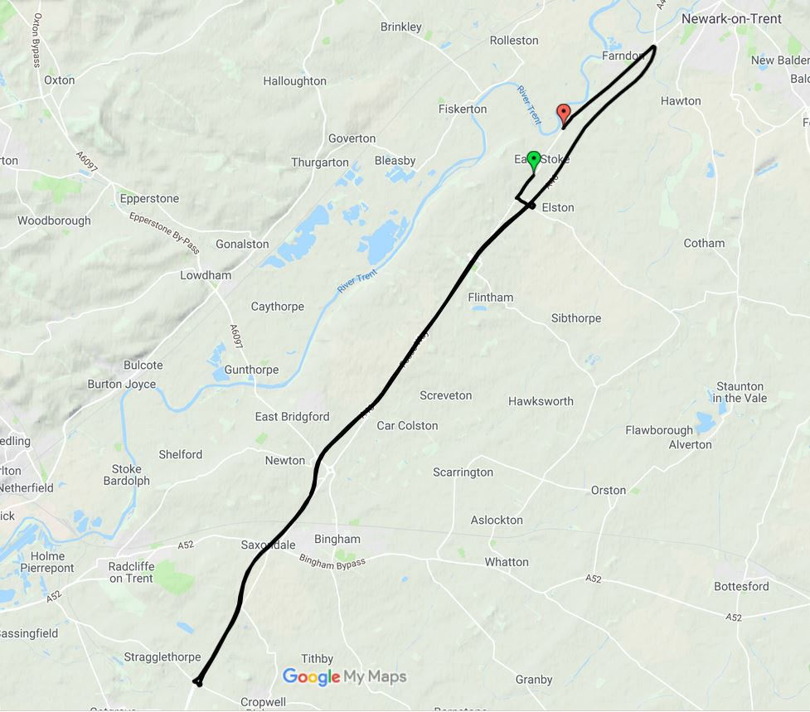

Safety Instructions for riders

- Competitors should not attend if they feel ill in ANY way or if family have any symptoms of COVID 19.
- Please wear a face covering whilst in the HQ.
- An elevated resting heartrate or exceptionally quick to react heartrate during warm up can suggest an underlying asymptomatic illness of ANY kind. You should NOT start the event (DNS) and leave immediately. Do not go to the start line if you feel this is the case and notify the organiser of your intention not to start as a result of adverse warmup.
- Warmups please use the old A46 north of the start but be aware of earlier starting competitors approaching the finish.
- Competitors please do not gather in any way regardless of current guidelines in the carpark/HQ area or elsewhere.
- Competitors must not leave any personal items with the timekeeper.
- Competitors on finishing MUST NOT stop at finish and MUST NOT loiter at the HQ/carpark please sign out then pack away and leave immediately upon completion of the race.
- It is strongly advised that all competitors carry a mobile phone and take with them the telephone number of the event organiser. Please telephone the organiser if you have failed to finish the event.
- Please do not arrive at the start line more than 5 minutes before your start time as there is limited space to maintain social distancing.
- There will be no pusher off and all competitors will need to start with one foot on the ground.
- All competitors must start the race with a working red rear light. NO LIGHT? NO START!
- Please bring your own pen to sign in and own safety pins.
- You MUST personally sign back in again upon completion of your ride otherwise YOU WILL receive a DNF!
- Please deposit the number in the bag provided ready for cleaning.
- Please ensure if you pass the finish timekeeper on the way to the start that it is plain that you are not racing.
Prizes
No formal presentation or results are planned after the event. Results will be uploaded once verified and as soon as they are made available. Prizes will be posted out to riders after the event and within 28 days.
1st Overall £40
2nd Overall £30
3rd Overall £20
4th Overall £10
Ladies
1st Overall £40
2nd Overall £30
3rd Overall £20
4th Overall £10
Tandem
1st Overall £20

Course Record Solo Men £25

Course Record Solo Ladies £25

Course Record Tandem £25

Course Records
Solo Male 46:57
Solo Female 50:42
Tandem 47:46
Solo Male Junior 47:31
Solo female Junior 1:03:13

We hope that you have an enjoyable, swift and safe ride. Good Luck.

